AI Tools for Academic Research
Introduction
A research project mainly has 6 steps.
- Select a simple Topic – a narrow and manageable topic
- Define the problem/question - What do you want to find out
- Review the exciting information - Books, journals, articles, websites
- Collect data – surveys, experiments, secondary sources.
- Analyze results – Basic statistics, comparison, or summaries
- Write the report – Intro -> Method -> Results -> Conclusion
AI tools have the potential to transform those stages of a research project. Nowadays, there are many tools to assist in academic research activities. Now let's check how these tools help these stages
Examples: - Consensus, library.scholarey.com, elicit.com, research.rabbit.com, connectedpapers.com, tableau.com, app.powerbi.com, scispace.com

Tools
Consensus – This AI tool mainly works as a search engine for research and papers. It gives us a summary of many research papers, and it's totally free. Its premium version has more benefits
Library.scholarcy.com – This is an AI-powered platform that provides the ability to summarize research papers, textbooks, and long documents that are difficult to read manually, as it takes a long time period. This assists students in focusing more on their creative perspective and academic work rather than focusing on reading for long hours.
Power BI – Power Business Intelligence. Though this AI tool is mainly related to business purposes, it has primarily provided the ability to convert raw, messy data into clean information by visualizing them in to charts, graphs, etc. With this, Power BI has provided the ability to assist in research projects. With the help of its strong analytical power, we can get the maximum use of this tool for building research materials. This is an AI model that provides the ability
Scispace – The most difficult task while preparing a research report is finding facts and the sources for those facts. Traditionally, a researcher had to spend a long-time finding fact and collecting data that is required for the report. Now researchers are capable of finding the necessary details with the help of the Scispace AI tool. This tool provides the ability to find and analyze previously prepared research papers and other websites related to the relevant topic. Not only is this tool capable of analyzing the documents submitted by the user, but it can also provide a proper summary related to the topic.
Current Situation
Nowadays, students tend to use AI tools in research projects. According to an online survey, higher education students have a positive attitude and awareness of these tools. They believe that these tools can revolutionize academic research. AI tools can also assist as a writing assistant.
Future Development
AI is developing rapidly towards the betterment of the world with the help of high analytical and computational power. Similarly, AI has been heavily involved in developing research papers nowadays. AI has provided the ability to find facts and information with ease within a short time period.
Advantages of using AI tools in academic research
- Ability to find raw facts and data necessary for research papers conveniently.
- Provides the ability to visualize the data required for research.
- Increases the speed and accuracy in finding information.
- Minimizes the risk of human errors.
- Reduces the time spent on a single research project.
Disadvantages
- Reduces the ability to think logically and the ability to convert raw data into information.
- Overdependency on AI tools can cause hidden errors in the data found.
- Lack of human judgment reduces the morality of the projects.
- Copyright issues can be caused
- Higher cost, as most of the AI tools require a paid version to obtain maximum use of them.
Responsible use of AI tools in academic research
In stages 1, 2 & 6, researchers must use their own ability to complete those stages rather than using AI, since these stages should include the concepts developed by the researcher himself. In stages 3-5, we can use AI tools within limits and can boost our research and efficiency. We can read more research project tools and pages. Also use data analysis tools for further development of the research project. While using AI as an intelligent assistant for academic use, human involvement is a must; various negative impacts may occur to the research projects.
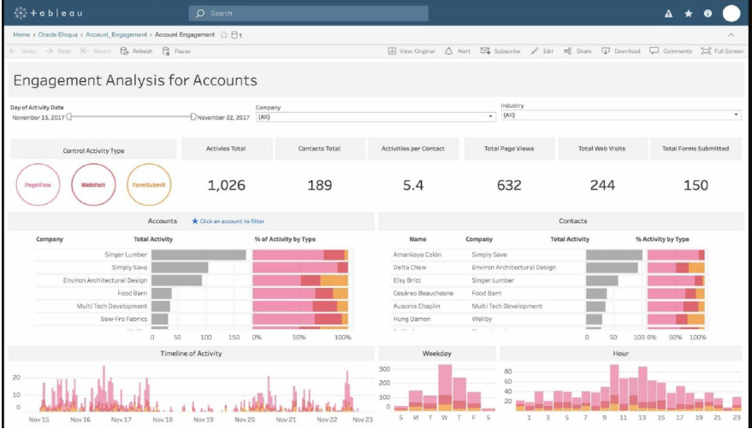
The impact of intelligence on student performance and schools is a big deal. Artificial intelligence helps make learning and grading personal for each student. Researchers looked at what happened with one hundred and fifteen students who used AI. They wanted to see if using intelligence really made a difference in how well students did in school. The researchers used math tools like correlation analysis and chi-square tests and parabolic distribution modeling to understand the relationship between using artificial intelligence and how well students did in school. Artificial intelligence and student performance are what they focused on. They used all these tools to see how artificial intelligence affects student performance and the school environment.
Refernces
M. Al-Zahrani(2023.10.15)- https://www.tandfonline.com/doi/full/10.1080/14703297.2023.2271445
Emerald Publishing(2024.10.10)- https://www.emerald.com/lhtn/article-abstract/41/8/18/1233085/Artificial-intelligence-AI-tools-for-academic?redirectedFrom=fulltext
Youtube-https://www.youtube.com/watch?v=au7u4Y8p1pM
International Journal of Scientific Research in Engineering and Management (IJSREM)(2025.01.01)- https://ijsrem.com/uploads/production/APPLICATION-OF-AI-TOOLS-IN-RESEARCH.pdf

